**Lesson 8 Demo 8**

**Update Application**

**Objective:** To update Application

**Tools required:** kubeadm, kubectl, kubelet, and etcd

**Prerequisites**: A Kubernetes cluster must be configured (follow the steps in Lesson 8 Demo 1)

Steps to be followed:

1. Creating a Deployment using the image portainer/portainer:1.24.2-alpine by using the following command
2. Verifying Deployment and Pods by using the following command
3. Scaling the Deployment for a better understanding
4. Setting a new image version for the portainer Deployment
5. Showing Pods terminating and new instances

**Step** **1: Creating a Deployment using image portainer/portainer:1.24.2-alpine by using the following command**

kubectl create deployment portainer --image=portainer/portainer:1.24.2-alpine



**Step 2: Verifying Deployment and Pods by using the following command**

kubectl get deployment

kubectl get pods

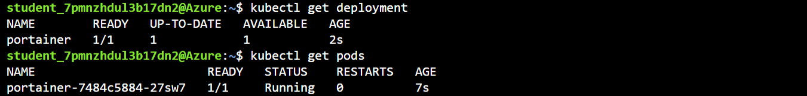

**Step 3: Scaling the Deployment for a better understanding**

kubectl scale --replicas=3 deployment/portainer

**Step 4: Setting a new image version for the portainer Deployment**

kubectl set image deployment portainer portainer=portainer/portainer:1.25.0-alpine

|  |
| --- |
| Note: Step 4: To monitor the deployment, use the kubectl get pod command. As the updated application is deployed, your Pods are terminated and re-created with the new container image. Use the following command to set a new version of the image. |

**Step 5: Showing Pods terminating and new instances running as the Deployment progresses**

kubectl get pods

